



***Logical & Physical Data Model Document***

Banking Enforcement Automation

Author Name: SBM Team

Version No:   Version 1.6

Issue Date:    8 December 2019

**Table of Contents**

1 Introduction 7

1.1 Description 7

1.2 Purpose 8

1.3 Reference 8

2 Subject Area: Common Tables 9

2.1 Logical Data Model (LDM) 9

**2.1.1** **Agency Service Request** 10

**2.1.2** **Agency Service Request Status** 11

**2.1.3** **Request Header More Info** 12

**2.1.4** **Request Header Note** 12

**2.1.5** **Agency Service Request Reviewer Notes** 12

**2.1.6** **Third Party** 13

**2.1.7** **Involved Party** 13

**2.1.8** **Executor Service Task** 13

**2.1.9** **Executor Service Task Status** 14

**2.1.10** **Executor Service Task Reviewer Notes** 14

**2.1.11** **Product joint Account** 15

**2.1.12** **Product Shares** 15

**2.1.13** **Product User List** 15

**2.1.14** **Tracking Assignment** 16

**2.1.15** **Active SLA Instance** 16

2.2 Physical Data Model (PDM) 17

2.3 Lookup Table 18

3 Subject Area: Wave 1 - General Inquiry Process 18

3.1 Logical Data Model (LDM) 18

**3.1.1** **Account Information Request** 21

**3.1.2** **Account Information Response** 21

**3.1.3** **Account Balance Information Request** 21

**3.1.4** **Account Balance Information Response** 21

**3.1.5** **Account Balance Information Reservation** 22

**3.1.6** **Deposit Information Request** 23

**3.1.7** **Deposit Information Response** 23

**3.1.8** **Liabilities Information Request** 23

**3.1.9** **Liabilities Information Response** 24

**3.1.10** **Safe Information Request** 25

**3.1.11** **Safe Information Response** 25

4 Subject Area: Wave 2 - Execution Process 25

4.1 Logical Data Model (LDM) 25

**4.1.1** **Ban Execution Request** 27

**4.1.2** **Ban Execution Response** 27

**4.1.3** **Block Execution Request** 28

**4.1.4** **Block Execution Response** 28

**4.1.5** **Deny Execution Request** 29

**4.1.6** **Deny Execution Response** 29

**4.1.7** **Lift Execution Request** 29

**4.1.8** **Lift Execution Response** 30

**4.1.9** **Garnish Execution Request** 31

**4.1.10** **Garnish Execution Response** 31

**4.1.11** **Execution Account Info** 32

**Record of changes**

|  |  |  |  |
| --- | --- | --- | --- |
| **Date** | **Version** | **Author** | **Change details** |
| 23 December 2017 | 1.0 | SBM team | Initial version |
| 4 March 2018 | 1.1 | Mahmoud Gawad | Add column [ PROCESS_TYPE_CD ] to table [AGENCY SERVICE REQUEST] |
| 13 March 2018 | 1.2 | Mahmoud Gawad | Add table [ACTIVE SLA INSTANCE] |
| 20 March 2018 | 1.3 | Mahmoud Gawad | * Add [SLA_ENTITY_ID] column to table [ACTIVE SLA INSTANCE] * Add [ACTV_SLA_INSTANCE_FK] constraint to table [ACTIVE SLA INSTANCE] * Add unique constraint [ACTV_SLA_INSTANCE_UK1]to table [ACTIVE SLA INSTANCE] * Modify data type of column [BAL_DATE] to be date in table [ACC_BAL_INFO_RESP] |
| 25 March 2018 | 1.4 | Mahmoud Gawad | * Change length of [AGCY_SRVC_REQST_ID] As foreign key in tables [ACC_BAL_INFO_REQST , COMPANY , DEPOSIT_INFO_REQST , PERSON ] * Change length of [RESERVED_AMT] in table [ACC_BAL_INFO_RESERV] * Change length of [BOX_NO] in table [SAFE_INFO_REQST] * Change length of [DEPOSIT_BAL] in table [DEPOSIT_INFO_RESP] * Change length of [AVAILABLE_BAL , TOTAL_BAL ] in table [ACC_BAL_INFO_RESP] * Change length of [ACC_USER_NAME] in tables [ACC_INFO_RESP_USER , DEPOSIT_INFO_RESP_USER , SAFE_INFO_RESP_USER] * Change length of [EXETR_REF_NO] in table [EXETR_SRVC_TASK] * Change length of [REQSTR_PERSON_ID , SRVC_TYPE_CD , EXT_REF_NO ] in table [AGCY_SRVC_REQST] * Change length of [REVWR_1_ID, REVWR_1_NAME, REVWR_2_ID , REVWR_2_NAME] in tables [AGCY_SRVC_REQST_REVWR_NOTES , EXETR_SRVC_TASK_REVWR_NOTES] * Change length of [TOTAL_LIAB_AMT , REMAINING_LIAB_AMT , INSTAL_AMT] in table [LIAB_INFO_RESP] |
| 19 April 2018 | 1.41 | Mahmoud Gawad | * Change ID_NO on Government table to accept null values |
| 3 May 2018 | 1.42 | Mahmoud Gawad | * Drop Column ID on THIRD_PARTY table * ADD Column ID_NO to THIRD_PARTY table |
| 30 May 2018 | 1.43 | Mahmoud Gawad | * ADD Column JNT_ACC to table ACC_INFO_RESP * ADD Column JNT_ACC to table ACC_BAL_INFO_RESP * ADD Column JNT_ACC to table DEPOSIT_INFO_RESP * ADD Column JNT_ACC to table SAFE_INFO_RESP |
| 16 July 2018 | 1.44 | Mahmoud Gawad | * ADD Column CHANNEL_CD to table EXETR_SRVC_TASK * ADD Column INST to table ACC_BAL_INFO_RESP * Modify Column ACC_TYPE at table ACC_INFO_RESP * Modify Column ACC_TYPE at table ACC_BAL_INFO_RESP * Modify Column SAFE_BRANCH at table SAFE_INFO_RESP * Modify Column TYPE_OF_LIAB at table LIAB_INFO_RESP |
| 8 August | 1.45 | Mahmoud Gawad | * Drop Constraint ACC_INFO_RESP_USER_FK * Add table LIAB_INFO_RESP_USER * Add SEQUENCE "LIAB_INFO_RESP_USR_SEQ" * Add Constraint LIAB_INFO_RESP_USER_FK |
| 14 January 2019 | 1.5 | Mohamed Ramadan | * Drop unneeded wave 1 tables * Add wave 2 tables * Classify table to three categories: [wave1 tables, wave2 tables, common tables] |
| 8 December 2019 | 1.6 | Mohamed Elsayed | * Add SLA Configuration tables |

**Distribution List**

|  |  |
| --- | --- |
| **MOJ** |  |
| **SAMA UAT/Testing** |  |
| **Solution Delivery** |  |
| **Project Sponsor** |  |
| **Project Manager** |  |
| **Architecture Solution Unit** |  |

**Approvals List**

|  |  |  |  |
| --- | --- | --- | --- |
| **Name** | **Role** | **Signature** | **Date** |
|  | SAMA Architecture Representative |  | Date of Approval |
|  | SAMA Solution Delivery |  |  |
|  | SAMA SOC team |  |  |
|  |  |  |  |
|  |  |  |  |

*Approvals can be obtained by e-mails, or document sign-off*

# Introduction

This document contains Data Model (DM) developed for the SAMA Banking enforcement project ***(TANFEETH****)*.

## Description

The Data Model (DM) is created considering the application requirements for Banking enforcement solution ***(TANFEETH****)*.

A data model is a major component of an application system that describes what sort of data, the relationships between the data elements, and how it will be organized in the database.

There are two types of data models

1. Logical
2. Physical.

A **logical data model** represents data in terms of entities and attributes independent of any particular RDBMS technology, where as a **physical** **data model** considers the facilities and constraints of a specific RDBMS and data is organized in form of Tables, and Columns.

A logical model is transformed into physical model for physical implementation.

The ***TANFEETH*** DM will be divided into a number of subject areas. A subject area is a logical grouping of entities created for storing data related to a specific business area or process.

In general focus of each subject area will be one of the process and related services that will be implemented as part of the overall **TANFEETH** solution the data model will be extended as new process/services are implemented starting with “General Inquiry” subject area.

The LDM is in third normal form (3NF). Normalization is a process for organizing tables and fields to avoid data inconsistence and anomalies. There are several normal forms, 3NF is widely used and is considered as an industry standard for implementing databases. 3NF data models are flexible and can be easily extended to accommodate new entities and attributes and this is one of the reasons for their popularity and wide acceptance.

A separate chapter for each subject area is included in this document.

The document starts with Wave 1 process “General Inquiry” and will be extended for Wave 2 and Wave 3 processes/services

## Purpose

The purpose of the Data Model document is to represent the solution in terms of entities and attributes relationships between the entities, and how it will be organized in the database. independent of any particular RDBMS technology,

## Reference

This document is based on and refers to the following documents:

* + Business requirement document for General Inquiry process (Approved version).

# Subject Area: Common Tables

## Logical Data Model (LDM)

Logical Data Model for General Inquiry process/ services subject area is given below, an embedded object for the same is included in the next section for easy of viewing.

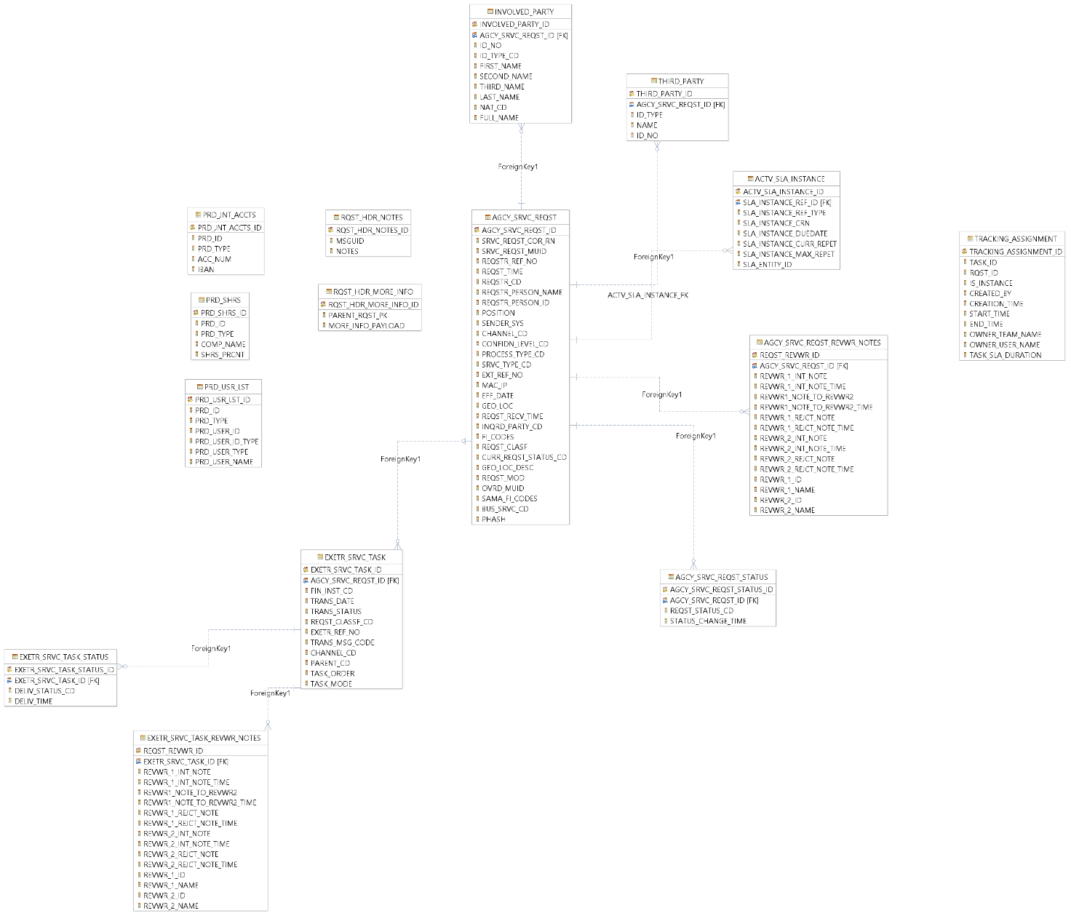

Figure : Inquiry Subject Area – Logical Data Model

Inquiry Subject Area – Embedded Object (Logical Data Model)

Logical data model of subject area Inquiry is included below as an embedded object for easy of viewing:

The following table includes all the entities and attributes of “General Inquiry” subject area shown in figure 1.

**Note**: Names used for entity/attributes are self-explanatory/intuitive.

Description is included only where further explanation is considered helpful.

**List of Entitles**

### **Agency Service Request**

|  |  |  |  |
| --- | --- | --- | --- |
|  | Attribute Name | Attribute Definition | DB Field Name |
| 1 | Agency Service Request Identifier | System generated Primary Key (PK ) | AGCY_SRVC_REQST_ID |
| 2 | Service Request Correlation Reference | Correlation reference between systems in case of queued requests | SRVC_REQST_COR_RN |
| 3 | Service Request Message ID | This will be a universal message identifier from the source | SRVC_REQST_MUID |
| 4 | Sender System | This is used to identify the system who initiated the request (Service consumer identifier) | SENDER_SYS |
| 5 | Requester Reference Number | Requesting party reference number which will be a reference for the involved party (for example the Case number for MOJ) | REQSTR_REF_NO |
| 6 | External Reference Number | Some requests could come via physical paper, it may have a reference number and a letter number, we can store the letter number in this attribute | EXT_REF_NO |
| 7 | Request Time | Time when the Message is initiated from the source (Request message creation time) | REQST_TIME |
| 8 | Request receive Time | This attribute represents the exact time of receiving the message itself | REQST_RECV_TIME |
| 9 | Requester Code | Partner Identity which initiate the request | REQSTR_CD |
| 10 | Channel Code | Code used to determine the channel | CHANNEL_CD |
| 11 | Requester Person Name | Request initiator name. | REQSTR_PERSON_NAME |
| 12 | Requester Person ID | Request initiator ID | REQSTR_PERSON_ID |
| 13 | Position | Request initiator position | POSITION |
| 14 | Confidentiality Level Code | The requesting party classification of the request regarding confidentiality level | CONFIDN_LEVEL_CD |
| 15 | Service Type Code | Code to identify which service was called | SRVC_TYPE_CD |
| 16 | Machine IP | IP address of the service consumer system | MAC_IP |
| 17 | Effective Date | Effective date of request execution | EFF_DATE |
| 18 | Geo Location | The Request initiator geo location and the internal division inside the entity which will be agreed upon on a requesting parties one-on-one basis | GEO_LOC |
| 19 | Geo Location Description | The description of the geo location | GEO_LOC_DESC |
| 20 | Inquired Party Code | Code to identify type of involved party | INQRD_PARTY_CD |
| 21 | financial institution Codes | Request Financial Institution list of codes comma separated | FI_CODES |
| 22 | Request Classification | SAMA request classification for assignment of the request to a proper bank role. | REQST_CLASF |
| 23 | Request mode | Request mode | REQST_MOD |
| 24 | Process Type Code | Process Type Code | PROCESS_TYPE_CD |
| 25 | Current Request Status Code | Request status | CURR_REQST_STATUS_CD |
| 26 | Override Message identification | Override Message Identification | OVRD_MUID |
| 27 | SAMA Financial Institution code | Executed Financial Institution list of codes comma separated | SAMA_FI_CODES |
| 28 | Business service code | Business service code | BUS_SRVC_CD |
| 29 | Previous hash | Blockchain enabled feature for future use. | PHASH |

### **Agency Service Request Status**

|  |  |  |  |
| --- | --- | --- | --- |
|  | Attribute Name | Attribute Definition | DB Field Name |
| 1 | Agency Service Request Status ID | System generated Primary Key (PK ) | AGCY_SRVC_REQST_STATUS_ID |
| 2 | Agency Service Request Identifier | Foreign Key (FK) to [Agency Service Request] | AGCY_SRVC_REQST_ID |
| 3 | Request Status Code | Request status | REQST_STATUS_CD |
| 4 | Status Change Time | The time of changing request status | STATUS_CHANGE_TIME |

### **Request Header More Info**

|  |  |  |  |
| --- | --- | --- | --- |
|  | Attribute Name | Attribute Definition | DB Field Name |
| 1 | Request header more info identifier | DB system generated primary key (PK) | RQST_HDR_MORE_INFO_ID |
| 2 | Parent request primary key | Foreign key (FK) for parent request | PARENT_RQST_PK |
| 3 | More info payload | More info payload | MORE_INFO_PAYLOAD |

### **Request Header Note**

|  |  |  |  |
| --- | --- | --- | --- |
|  | Attribute Name | Attribute Definition | DB Field Name |
| 1 | Request header notes denier | DB system generated primary key (PK) | RQST_HDR_NOTES_ID |
| 2 | Message identifier | Message identification | MSGUID |
| 3 | Notes | Notes | NOTES |

### **Agency Service Request Reviewer Notes**

|  |  |  |  |
| --- | --- | --- | --- |
|  | Attribute Name | Attribute Definition | DB Field Name |
| 1 | Request Reviewer ID | System generated Primary Key (PK ) | REQST_REVWR_ID |
| 2 | Agency Service Request Identifier | Foreign Key (FK) to [Agency Service Request] | AGCY_SRVC_REQST_ID |
| 3 | Reviewer_1 ID | Reviewer_1 ID | REVWR_1_ID |
| 4 | Reviewer_1 Name | Reviewer_1 Name | REVWR_1_NAME |
| 5 | Reviewer_2 ID | Reviewer_2 ID | REVWR_2_ID |
| 6 | Reviewer_2 Name | Reviewer_2 Name | REVWR_2_NAME |
| 7 | Reviewer_1 Internal Note | Reviewer_1 Comment | REVWR_1_INT_NOTE |
| 8 | Reviewer_1 Internal Note Timestamp | Reviewer_1 Comment time | REVWR_1_INT_NOTE_TIME |
| 9 | Reviewer_1 to Reviewer_2 | Reviewer_1 to Reviewer_2 | REVWR1_NOTE_TO_REVWR2 |
| 10 | Reviewer_1 to Reviewer_2Timestamp | Reviewer_1 to Reviewer_2Timestamp | REVWR1_NOTE_TO_REVWR2_TIME |
| 11 | Reviewer_1 Rejection Note | Reviewer_1 Rejection Comment | REVWR_1_REJCT_NOTE |
| 12 | Reviewer_1 Rejection Note Timestamp | Reviewer_1 Rejection Comment time | REVWR_1_REJCT_NOTE_TIME |
| 13 | Reviewer_2 Internal Note | Reviewer_2 Comment | REVWR_2_INT_NOTE |
| 14 | Reviewer_2 Internal Note Timestamp | Reviewer_2 Comment time | REVWR_2_INT_NOTE_TIME |
| 15 | Reviewer_2 Rejection Note | Reviewer_2 Rejection Comment | REVWR_2_REJCT_NOTE |
| 16 | Reviewer_2 Rejection Note Timestamp | Reviewer_2 Rejection Comment time | REVWR_2_REJCT_NOTE_TIME |

### **Third Party**

|  |  |  |  |
| --- | --- | --- | --- |
|  | Attribute Name | Attribute Definition | DB Field Name |
| 1 | Third Party ID | System generated Primary Key (PK ) | THIRD_PARTY_ID |
| 2 | Agency Service Request Identifier | Foreign Key (FK) to [Agency Service Request] | AGCY_SRVC_REQST_ID |
| 3 | ID | The Third party Id | ID |
| 4 | ID Type | The Third party Id Type | ID_TYPE |
| 5 | Name | The Third party Name | NAME |

### **Involved Party**

|  |  |  |  |
| --- | --- | --- | --- |
|  | Attribute Name | Attribute Definition | DB Field Name |
| 1 | Involved party identifier | DB system generated primary key (PK) | INVOLVED_PARTY_ID |
| 2 | Agency service request identifier | Foreign key (FK) for agency service request identification | AGCY_SRVC_REQST_ID |
| 3 | Identification number | Identification number | ID_NO |
| 4 | Identification number code | Identification type code | ID_TYPE_CD |
| 5 | First name | Involved party first name for individual type only | FIRST_NAME |
| 6 | Second name | Involved party second name for individual type only | SECOND_NAME |
| 7 | Third name | Involved party third name for individual type only | THIRD_NAME |
| 8 | Last name | Involved party last name for individual type only | LAST_NAME |
| 9 | Nationality code | Involved party nationality code for individual type only | NAT_CD |
| 10 | Full name | Name of all involved party types | FULL_NAME |

### **Executor Service Task**

|  |  |  |  |
| --- | --- | --- | --- |
|  | Attribute Name | Attribute Definition | DB Field Name |
| 1 | Executor Service Task Identifier | System generated Primary Key (PK ) | EXETR_SRVC_TASK_ID |
| 2 | Agency Service Request Identifier | Foreign Key (FK) to [Agency Service Request] | AGCY_SRVC_REQST_ID |
| 3 | Financial Institution Code | Financial Institution list of codes comma separated | FIN_INST_CD |
| 4 | Transaction Date | Transaction Date | TRANS_DATE |
| 5 | Executor Reference Number |  | EXETR_REF_NO |
| 6 | Transaction Status | Status of the transaction () | TRANS_STATUS |
| 7 | Transaction Message Code | Status for the Bank message | TRANS_MSG_CODE |
| 8 | Channel code | Code of the channel | CHANNEL_CD |
| 9 | Request Classification Code | SAMA request classification for assignment of the request to a proper bank role. | REQST_CLASSF_CD |
| 10 | Parent code | Parent task code Foreign Key (FK) to [Executor Service Task] | PARENT_CD |
| 11 | Task order | Task execution order | TASK_ORDER |
| 12 | Task mode | Task execution mode | TASK_MODE |

### **Executor Service Task Status**

|  |  |  |  |
| --- | --- | --- | --- |
|  | Attribute Name | Attribute Definition | DB Field Name |
| 1 | Executor Service Task Status ID | System generated Primary Key (PK ) | EXETR_SRVC_TASK_STATUS_ID |
| 2 | Executor Service Task Identifier | Foreign Key (FK) to [Executor Service Task] | EXETR_SRVC_TASK_ID |
| 3 | Delivery Status Code | Delivery Status | DELIV_STATUS_CD |
| 4 | Delivery Time | The Time of Delivery | DELIV_TIME |

### **Executor Service Task Reviewer Notes**

|  |  |  |  |
| --- | --- | --- | --- |
|  | Attribute Name | Attribute Definition | DB Field Name |
| 1 | Request Reviewer ID | System generated Primary Key (PK ) | REQST_REVWR_ID |
| 2 | Executor Service Task Identifier | Foreign Key (FK) to [Executor Service Task] | EXETR_SRVC_TASK_ID |
| 3 | Reviewer_1 ID | Reviewer_1 ID | REVWR_1_ID |
| 4 | Reviewer_1 Name | Reviewer_1 Name | REVWR_1_NAME |
| 5 | Reviewer_2 ID | Reviewer_2 ID | REVWR_2_ID |
| 6 | Reviewer_2 Name | Reviewer_2 Name | REVWR_2_NAME |
| 7 | Reviewer_1 Internal Note | Reviewer_1 Comment | REVWR_1_INT_NOTE |
| 8 | Reviewer_1 Internal Note Timestamp | Reviewer_1 Comment time | REVWR_1_INT_NOTE_TIME |
| 9 | Reviewer_1 to Reviewer_2 | Reviewer_1 to Reviewer_2 | REVWR1_NOTE_TO_REVWR2 |
| 10 | Reviewer_1 to Reviewer_2 Timestamp | Reviewer_1 to Reviewer_2 Timestamp | REVWR1_NOTE_TO_REVWR2_TIME |
| 11 | Reviewer_1 Rejection Note | Reviewer_1 Rejection Comment | REVWR_1_REJCT_NOTE |
| 12 | Reviewer_1 Rejection Note Timestamp | Reviewer_1 Rejection Comment time | REVWR_1_REJCT_NOTE_TIME |
| 13 | Reviewer_2 Internal Note | Reviewer_2 Comment | REVWR_2_INT_NOTE |
| 14 | Reviewer_2 Internal Note Timestamp | Reviewer_2 Comment time | REVWR_2_INT_NOTE_TIME |
| 15 | Reviewer_2 Rejection Note | Reviewer_2 Rejection Comment | REVWR_2_REJCT_NOTE |
| 16 | Reviewer_2 Rejection Note Timestamp | Reviewer_2 Rejection Comment time | REVWR_2_REJCT_NOTE_TIME |

### **Product joint Account**

|  |  |  |  |
| --- | --- | --- | --- |
|  | Attribute Name | Attribute Definition | DB Field Name |
| 1 | Product Joint Accounts identifier | DB system generated primary key (PK) | PRD_JNT_ACCTS_ID |
| 2 | Product identification | Product identification | PRD_ID |
| 3 | Product type | Product type that value can be [GI Acc info, Acc balance, deposit, Liability, Block account info, etc] | PRD_TYPE |
| 4 | Account number | Account number | ACC_NUM |
| 5 | Account number in IBAN format | Account number in IBAN format | IBAN |

### **Product Shares**

|  |  |  |  |
| --- | --- | --- | --- |
|  | Attribute Name | Attribute Definition | DB Field Name |
| 1 | Product shares identification | DB system generated primary key (PK) | PRD_SHRS_ID |
| 2 | Product identifier | Product identifier | PRD_ID |
| 3 | Product type | Product type that value can be [GI Acc info, Acc balance, deposit, Liability, Block account info, etc] | PRD_TYPE |
| 4 | Company name | Company name | COMP_NAME |
| 5 | Shares percentage | Shares percentage | SHRS_PRCNT |

### **Product User List**

|  |  |  |  |
| --- | --- | --- | --- |
|  | Attribute Name | Attribute Definition | DB Field Name |
| 1 | Product user list identifier | DB system generated primary key (PK) | PRD_USR_LST_ID |
| 2 | Product identifier | Foreign key (FK) for Product identifier | PRD_ID |
| 3 | Product type | Product type that value can be [GI Acc info, Acc balance, deposit, Liability, Block account info, etc] | PRD_TYPE |
| 4 | Product user identification | Product user identification | PRD_USER_ID |
| 5 | Product user identification type | Product user identification type | PRD_USER_ID_TYPE |
| 6 | Product user type | Product user type | PRD_USER_TYPE |
| 7 | Product user name | Product user name | PRD_USER_NAME |

### **Tracking Assignment**

|  |  |  |  |
| --- | --- | --- | --- |
|  | Attribute Name | Attribute Definition | DB Field Name |
| 1 | Task_id | Task identifier | TASK_ID |
| 2 | Rqst_id | Request identifier | RQST_ID |
| 3 | Is instance | Is instance flag | IS_INSTANCE |
| 4 | Created by | Who create this | CREATED_BY |
| 5 | Creation time | Time of creation | CREATION_TIME |
| 6 | Start time | Actual start time | START_TIME |
| 7 | End time | Actual end time | END_TIME |
| 8 | Owner_user_name | User name of the owner | OWNER_USER_NAME |
| 9 | Owner_team_name | Team name of the owner | OWNER_TEAM_NAME |
| 10 | Task Service line agreement duration | Task Service line agreement duration | TASK_SLA_DURATION |
| 11 | Tracking assignment identification | Tracking assignment identification | TRACKING_ASSIGNMENT_ID |

### **Active SLA Instance**

|  |  |  |  |
| --- | --- | --- | --- |
|  | Attribute Name | Attribute Definition | DB Field Name |
| 1 | Active SLA instance id | System generated Primary Key (PK ) | ACTV_SLA_INSTANCE_ID |
| 2 | SLA reference identifier | Foreign Key (FK) to [Agency Service Request] | SLA_INSTANCE_REF_ID |
| 3 | Type of SLA reference identifier | Type of SLA reference identifier | SLA_INSTANCE_REF_TYPE |
| 4 | SLA Correlation Reference Number | SLA Correlation Reference Number | SLA_INSTANCE_CRN |
| 5 | SLA entity Identifier | Identifier of SLA entity | SLA_ENTITY_ID |
| 6 | SLA Due Date | SLA Due Date | SLA_INSTANCE_DUEDATE |
| 7 | Max number to repeat | Max number to repeat | SLA_INSTANCE_MAX_REPET |
| 8 | Current repeat number | Current repeat number | SLA_INSTANCE_CURR_REPET |

### **SLA_SRV_TMPL**

|  |  |  |  |
| --- | --- | --- | --- |
|  | Attribute Name | Attribute Definition | DB Field Name |
| 1 | Service Code | Service code like accinfo , block ,ban,….etc [codes exists in LOV table] | SRV_CODE |
| 2 | Template Code | Template Id used to configure SLA times for this service | TMPL_CODE |

### **SLA_TMPL_SETTINGS**

|  |  |  |  |
| --- | --- | --- | --- |
|  | Attribute Name | Attribute Definition | DB Field Name |
| 1 | Template Code | Template Id used to configure SLA times for this service | TMPL_CODE |
| 2 | Cycle | Cycle of communication between TANFEETH and any external Party  It could be with [Requesting Party – Financial Institution [B2B] - Financial Institution [Portal]] side. | CYCLE |
| 3 | Channel | Channel of communication between TANFEETH and any external party it could be [B2B-Portal] | CH_ID |
| 4 | Level | Level of SLA, values from 0 to 3 | LVL |
| 5 | SLA Period | SLA Period in Minutes | PERIOD |

## Physical Data Model (PDM)

Physical data model of subject area General Inquiry process/ services is included below, an embedded object for easy of viewing is included in the subsequent section

Inquiry Subject Area – Embedded Object (Physical Data Model)

Physical data model of Inquiry subject area shown in figure 2 is included below as an embedded object for easy of viewing:



## Lookup Table

A generic lookup table is included in the Data Model for defining the lookup values, the physical structure is included in Appendix, and the logical structure is as below:

|  |  |  |
| --- | --- | --- |
|  | **Model : Sama** |  |
|  | **Subject Area : common** |  |
|  | **Entity Name : LOV** |  |
|  | Attribute Name | Attribute Definition |
|  | Identifier | Primary Key (PK ) |
|  | ListOfValue Parent |  |
|  | Type Code |  |
|  | Description |  |
|  | Short Description |  |
|  | Attribute 1 |  |
|  | Attribute 2 |  |
|  | Attribute 3 |  |
|  | Attribute 4 |  |
|  | Attribute 5 |  |
|  | Attribute 6 |  |
|  | Attribute 7 |  |
|  | Attribute 8 |  |
|  | Attribute 9 |  |
|  | Active |  |
|  | ListOfValue Code 1 |  |
|  | ListOfValue Code 2 |  |
|  | ListOfValue Code 3 |  |

# Subject Area: Wave 1 - General Inquiry Process

General Inquiry subject area covers entities defined for storing information related to Inquiries services received from Government agencies against individuals, companies, and government organizations related to accounts, deposits, safe, and liabilities maintained by financial institutions.

## Logical Data Model (LDM)

Logical Data Model for General Inquiry process/ services subject area is given below, an embedded object for the same is included in the next section for easy of viewing.

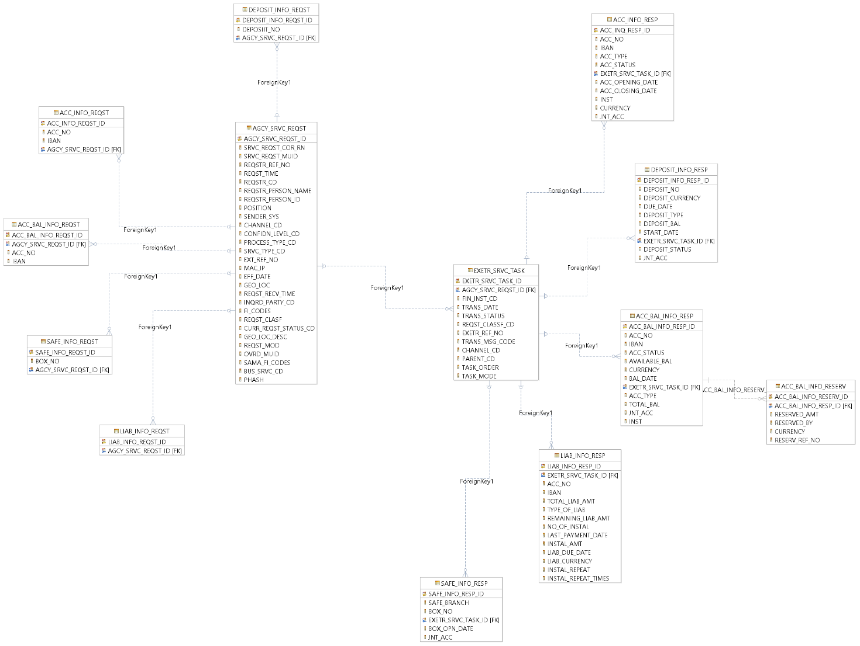

Figure : Inquiry Subject Area – Logical Data Model

Inquiry Subject Area – Embedded Object (Logical Data Model)

Logical data model of subject area Inquiry is included below as an embedded object for easy of viewing:

The following table includes all the entities and attributes of “General Inquiry” subject area shown in figure 1.

**Note**: Names used for entity/attributes are self-explanatory/intuitive.

Description is included only where further explanation is considered helpful.

**List of Entitles**

### **Account Information Request**

|  |  |  |  |
| --- | --- | --- | --- |
|  | Attribute Name | Attribute Definition | DB Field Name |
| 1 | Account Information Request Identifier | System generated Primary Key (PK ) | ACC_INFO_REQST_ID |
| 2 | Agency Service Request Identifier | Foreign Key (FK) to [Agency Service Request] | AGCY_SRVC_REQST_ID |
| 3 | Account Number | Involved party’s account number | ACC_NO |
| 4 | IBAN | Is IBAN or not | IBAN |

### **Account Information Response**

|  |  |  |  |
| --- | --- | --- | --- |
|  | Attribute Name | Attribute Definition | DB Field Name |
| 1 | Account Inquiry Response Identifier | System generated Primary Key (PK ) | ACC_INQ_RESP_ID |
| 2 | Executor Service Task Identifier | Foreign Key (FK) to [Executor Service Task] | EXETR_SRVC_TASK_ID |
| 3 | Account Number | Involved party’s account number | ACC_NO |
| 4 | IBAN | Account number in IBAN format | IBAN |
| 5 | Joint account | Joint account | JNT_ACC |
| 6 | Institution | The name of the small company that can have only one owner where involved party is the owner | INST |
| 7 | Account Type | Type of the account description | ACC_TYPE |
| 8 | Account Status | Account status | ACC_STATUS |
| 9 | Account Currency | Account Currency | CURRENCY |
| 10 | Account Opening Date | Account opening date | ACC_OPENING_DATE |
| 11 | Account Closing Date | Account closing date | ACC_CLOSING_DATE |

### **Account Balance Information Request**

|  |  |  |  |
| --- | --- | --- | --- |
|  | Attribute Name | Attribute Definition | DB Field Name |
| 1 | Account Balance Information Request Identifier | System generated Primary Key (PK ) | ACC_BAL_INFO_REQST_ID |
| 2 | Agency Service Request Identifier | Foreign Key (FK) to [Agency Service Request] | AGCY_SRVC_REQST_ID |
| 3 | Account Number | Involved party’s account number | ACC_NO |
| 4 | IBAN | Is IBAN or not | IBAN |

### **Account Balance Information Response**

|  |  |  |  |
| --- | --- | --- | --- |
|  | **Attribute Name** | **Attribute Definition** | DB Field Name |
| 1 | Account Balance Information Response Identifier | System generated Primary Key (PK ) | ACC_BAL_INFO_RESP_ID |
| 2 | Executor Service Task Identifier | Foreign Key (FK) to [Executor Service Task] | EXETR_SRVC_TASK_ID |
| 3 | Account Number | Involved party’s account number | ACC_NO |
| 4 | IBAN | Account number in IBAN format | IBAN |
| 5 | Joint account | Joint account | JNT_ACC |
| 6 | Available Balance | The account balance can be (+,-) | AVAILABLE_BAL |
| 7 | Account Type | Type of the account description | ACC_TYPE |
| 8 | Total Balance | The Total balance is (the available amount + the total reserved amounts) can be (+,-) | TOTAL_BAL |
| 9 | Currency | Account Currency | CURRENCY |
| 10 | institution | institution | INST |
| 11 | Account Status | Account status | ACC_STATUS |
| 12 | Balance Date | Balance date | BAL_DATE |
|  |  |  |  |

### **Account Balance Information Reservation**

|  |  |  |  |
| --- | --- | --- | --- |
|  | Attribute Name | Attribute Definition | DB Field Name |
| 1 | Account Balance Information Reservation ID | System generated Primary Key (PK ) | ACC_BAL_INFO_RESERV_ID |
| 2 | Account Balance Information Response Identifier | Foreign Key (FK) to [Account Balance Information Response] | ACC_BAL_INFO_RESP_ID |
| 3 | Reserved Amount | Amount that is reserved by somebody | RESERVED_AMT |
| 4 | Reserved By | Info about the institution who is holding reservation on reserved amount | RESERVED_BY |
| 5 | Currency | Account Currency | CURRENCY |
| 6 | Reservation Reference Number | Reservation Reference Number for the reservations requested by SAMA | RESERV_REF_NO |

### **Deposit Information Request**

|  |  |  |  |
| --- | --- | --- | --- |
|  | Attribute Name | Attribute Definition | DB Field Name |
| 1 | Deposit Information Request Identifier | System generated Primary Key (PK ) | DEPOSIT_INFO_REQST_ID |
| 2 | Agency Service Request Identifier | Foreign Key (FK) to [Agency Service Request] | AGCY_SRVC_REQST_ID |
| 3 | Deposit Number | Information on involved party’s specific deposit number to be inquired | DEPOSIIT_NO |

### **Deposit Information Response**

|  |  |  |  |
| --- | --- | --- | --- |
|  | Attribute Name | Attribute Definition | DB Field Name |
| 1 | Deposit Information Response Identifier | System generated Primary Key (PK ) | DEPOSIT_INFO_RESP_ID |
| 2 | Executor Service Task Identifier | Foreign Key (FK) to [Executor Service Task] | EXETR_SRVC_TASK_ID |
| 3 | Deposit Number | Involved party’s Deposit number | DEPOSIT_NO |
| 4 | Deposit Currency | Deposit Currency | DEPOSIT_CURRENCY |
| 5 | Start Date | Deposit start date | START_DATE |
| 6 | Deposit Status | Deposit Status | DEPOSIT_STATUS |
| 7 | Joint flag | Joint flag | JNT_ACC |
| 8 | Due Date | Deposit Due Date | DUE_DATE |
| 9 | Deposit Type | Type of the Deposit description | DEPOSIT_TYPE |
| 10 | Deposit Balance | The Deposit balance | DEPOSIT_BAL |

### **Liabilities Information Request**

|  |  |  |  |
| --- | --- | --- | --- |
|  | Attribute Name | Attribute Definition | DB Field Name |
| 1 | Liabilities Information Request Identifier | System generated Primary Key (PK ) | LIAB_INFO_REQST_ID |
| 2 | Agency Service Request Identifier | Foreign Key (FK) to [Agency Service Request] | AGCY_SRVC_REQST_ID |

### **Liabilities Information Response**

|  |  |  |  |
| --- | --- | --- | --- |
|  | Attribute Name | Attribute Definition | DB Field Name |
| 1 | Liabilities Information Response Identifier | System generated Primary Key (PK ) | LIAB_INFO_RESP_ID |
| 2 | Executor Service Task Identifier | Foreign Key (FK) to [Executor Service Task] | EXETR_SRVC_TASK_ID |
| 3 | Account Number | Involved party’s account number | ACC_NO |
| 4 | IBAN | Account number in IBAN format | IBAN |
| 5 | Total Liability Amount | Total liabilities amount | TOTAL_LIAB_AMT |
| 6 | Type of Liability | Type of the liability description | TYPE_OF_LIAB |
| 7 | The remaining Liability Amount | The remaining debt | REMAINING_LIAB_AMT |
| 8 | Number of Instalments | Number of Installments | NO_OF_INSTAL |
| 9 | Last Payment Date | Date of the last payment of the liability | LAST_PAYMENT_DATE |
| 10 | Instalment Amount | Installment amount | INSTAL_AMT |
| 11 | Liability Currency | Liability Currency | LIAB_CURRENCY |
| 12 | Installment Repeat | Installment Repeat | INSTAL_REPEAT |
| 13 | Liability Due Date | Liability due date | LIAB_DUE_DATE |
| 14 | Instalment repeat times | Instalment repeat times | INSTAL_REPEAT_TIMES |

### **Safe Information Request**

|  |  |  |  |
| --- | --- | --- | --- |
|  | Attribute Name | Attribute Definition | DB Field Name |
| 1 | Safe Information Request Identifier | System generated Primary Key (PK ) | SAFE_INFO_REQST_ID |
| 2 | Agency Service Request Identifier | Foreign Key (FK) to [Agency Service Request] | AGCY_SRVC_REQST_ID |
| 3 | Box Number | Information on involved party’s specific Safe Box number to be inquired | BOX_NO |

### **Safe Information Response**

|  |  |  |  |
| --- | --- | --- | --- |
|  | Attribute Name | Attribute Definition | DB Field Name |
| 1 | Safe Information Response Identifier | System generated Primary Key (PK ) | SAFE_INFO_RESP_ID |
| 2 | Executor Service Task Identifier | Foreign Key (FK) to [Executor Service Task] | EXETR_SRVC_TASK_ID |
| 3 | Box Number | Involved party’s Safe Box number | BOX_NO |
| 4 | Safe Branch | Bank branch of the safe | SAFE_BRANCH |
| 5 | Joint flag | Joint flag | JNT_ACC |
| 6 | Box Opening Date | Safe Box opening date | BOX_OPN_DATE |

# Subject Area: Wave 2 - Execution Process

General Inquiry subject area covers entities defined for storing information related to Inquiries services received from Government agencies against individuals, companies, and government organizations related to accounts, deposits, safe, and liabilities maintained by financial institutions.

## Logical Data Model (LDM)

Logical Data Model for General Inquiry process/ services subject area is given below, an embedded object for the same is included in the next section for easy of viewing.

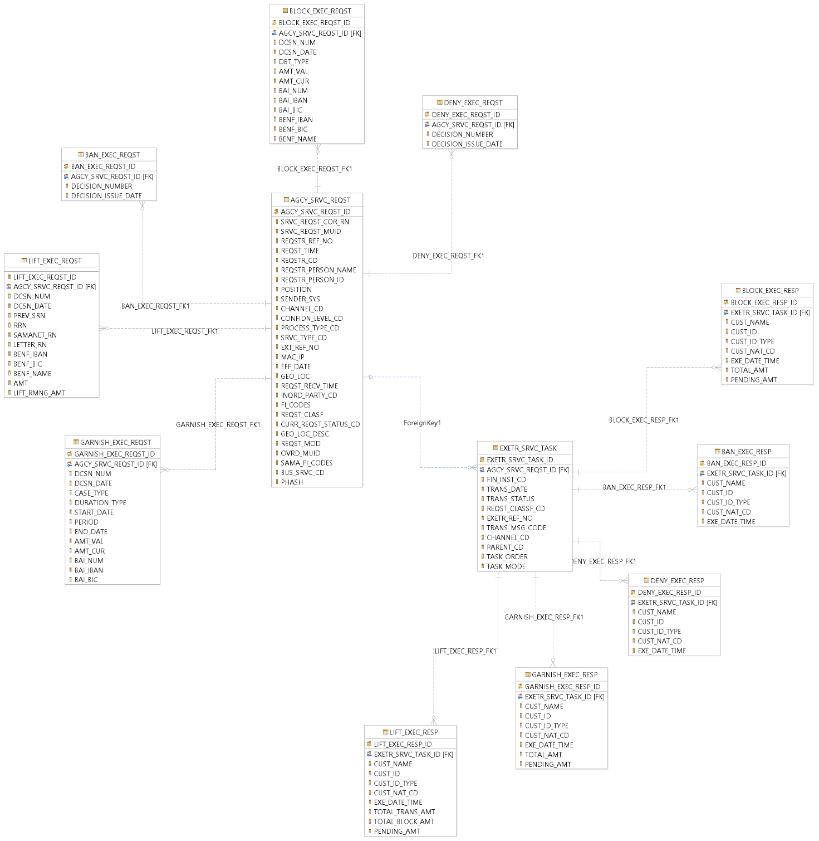

Figure : Inquiry Subject Area – Logical Data Model

Inquiry Subject Area – Embedded Object (Logical Data Model)

Logical data model of subject area Inquiry is included below as an embedded object for easy of viewing:

The following table includes all the entities and attributes of “General Inquiry” subject area shown in figure 1.

**Note**: Names used for entity/attributes are self-explanatory/intuitive.

Description is included only where further explanation is considered helpful.

**List of Entitles**

### **Ban Execution Request**

|  |  |  |  |
| --- | --- | --- | --- |
|  | Attribute Name | Attribute Definition | DB Field Name |
| 1 | Ban execution request identifier | DB system generated primary key (PK) | BAN_EXEC_REQST_ID |
| 2 | Agency service request identifier | Foreign Key (FK) to [Agency Service Request] | AGCY_SRVC_REQST_ID |
| 3 | Decision number | Ban decision number | DECISION_NUMBER |
| 4 | Decision issuing date | Ban decision issuing date | DECISION_ISSUE_DATE |

### **Ban Execution Response**

|  |  |  |  |
| --- | --- | --- | --- |
|  | Attribute Name | Attribute Definition | DB Field Name |
| 1 | Ban execution response identifier | DB system generated primary key (PK) | BAN_EXEC_RESP_ID |
| 2 | Executer service task identifier | Foreign Key (FK) to [Executor Service Task] | EXETR_SRVC_TASK_ID |
| 3 | Customer name | Banned customer name | CUST_NAME |
| 4 | Customer identifier | Banned customer identifier | CUST_ID |
| 5 | Customer identification type | Banned customer identification type | CUST_ID_TYPE |
| 6 | Customer nationality code | Banned customer nationality code | CUST_NAT_CD |
| 7 | Execution date time | Ban Execution date time | EXE_DATE_TIME |

### **Block Execution Request**

|  |  |  |  |
| --- | --- | --- | --- |
|  | Attribute Name | Attribute Definition | DB Field Name |
| 1 | Block execution request identifier | DB system generated primary key (PK) | BLOCK_EXEC_REQST_ID |
| 2 | Agency service request | Foreign Key (FK) to [Agency Service Request] | AGCY_SRVC_REQST_ID |
| 3 | Decision number | Block decision number | DCSN_NUM |
| 4 | Decision date | Block decision date | DCSN_DATE |
| 5 | Debt type | Debt type | DBT_TYPE |
| 6 | Amount value | Block amount value | AMT_VAL |
| 7 | Amount currency | Block amount currency | AMT_CUR |
| 8 | Bank Account identification number | Block Bank account identification number | BAI_NUM |
| 9 | Bank Account identification Account number in IBAN format | Block Bank Account identification Account number in IBAN format | BAI_IBAN |
| 10 | Bank Account Identification _ Bank Identification code | Block Bank code | BAI_BIC |
| 11 | Beneficiary Account number in IBAN format | Transfer beneficiary Account number in IBAN format | BENF_IBAN |
| 12 | Beneficiary Bank identification code | Transfer beneficiary Bank identification code | BENF_BIC |
| 13 | Beneficiary name | Transfer beneficiary name | BENF_NAME |

### **Block Execution Response**

|  |  |  |  |
| --- | --- | --- | --- |
|  | Attribute Name | Attribute Definition | DB Field Name |
| 1 | Block execution response identifier | DB system generated primary key (PK) | BLOCK_EXEC_RESP_ID |
| 2 | Executer service task identifier | Foreign Key (FK) to [Executor Service Task] | EXETR_SRVC_TASK_ID |
| 3 | Customer name | Blocked customer name | CUST_NAME |
| 4 | Customer identifier | Blocked customer identifier | CUST_ID |
| 5 | Customer identification type | Blocked customer identification type | CUST_ID_TYPE |
| 6 | Customer nationality code | Blocked customer nationality code | CUST_NAT_CD |
| 7 | Execution date and time | Block execution date and time | EXE_DATE_TIME |
| 8 | Total amount | Total blocked amount | TOTAL_AMT |
| 9 | Pending amount | Pending blocked amount | PENDING_AMT |

### **Deny Execution Request**

|  |  |  |  |
| --- | --- | --- | --- |
|  | Attribute Name | Attribute Definition | DB Field Name |
| 1 | Deny execution request identifier | DB system generated primary key (PK) | DENY_EXEC_REQST_ID |
| 2 | Agency service request identifier | Foreign Key (FK) to [Agency Service Request] | AGCY_SRVC_REQST_ID |
| 3 | Decision number | Deny decision number | DECISION_NUMBER |
| 4 | Decision issuing date | Deny decision issuing date | DECISION_ISSUE_DATE |

### **Deny Execution Response**

|  |  |  |  |
| --- | --- | --- | --- |
|  | Attribute Name | Attribute Definition | DB Field Name |
| 1 | Deny execution response identification | DB system generated primary key (PK) | DENY_EXEC_RESP_ID |
| 2 | Executor service task identification | Foreign Key (FK) to [Executor Service Task] | EXETR_SRVC_TASK_ID |
| 3 | Customer name | Denied customer name | CUST_NAME |
| 4 | Customer identifier | Denied customer identifier | CUST_ID |
| 5 | Customer identification type | Denied customer identification type | CUST_ID_TYPE |
| 6 | Customer nationality code | Denied customer nationality code | CUST_NAT_CD |
| 7 | Execution date and time | Deny execution date and time | EXE_DATE_TIME |

### **Lift Execution Request**

|  |  |  |  |
| --- | --- | --- | --- |
|  | Attribute Name | Attribute Definition | DB Field Name |
| 1 | Lift execution request identification | DB system generated primary key (PK) | LIFT_EXEC_REQST_ID |
| 2 | Agency service request identification | Foreign Key (FK) to [Agency Service Request] | AGCY_SRVC_REQST_ID |
| 3 | Decision number | Lift decision number | DCSN_NUM |
| 4 | Decision date | Lift decision date | DCSN_DATE |
| 5 | Previous SRN | Previous SAMA Tanfeeth Reference number | PREV_SRN |
| 6 | Reference number | Requester Reference number | RRN |
| 7 | SAMANET reference number | SAMANET reference number | SAMANET_RN |
| 8 | Letter reference number | Letter reference number | LETTER_RN |
| 9 | Beneficiary Account number in IBAN format | Transfer Beneficiary Account number in IBAN format | BENF_IBAN |
| 10 | Beneficiary BIC | Transfer Beneficiary BIC | BENF_BIC |
| 11 | Beneficiary name | Transfer Beneficiary name | BENF_NAME |
| 12 | Amount | Lift amount | AMT |
| 13 | Lift remaining amount | IS Lift remaining amount | LIFT_RMNG_AMT |

### **Lift Execution Response**

|  |  |  |  |
| --- | --- | --- | --- |
|  | Attribute Name | Attribute Definition | DB Field Name |
| 1 | Lift execution response identifier | DB system generated primary key (PK) | LIFT_EXEC_RESP_ID |
| 2 | Executor service task identifier | Foreign Key (FK) to [Executor Service Task] | EXETR_SRVC_TASK_ID |
| 3 | Customer name | Lifted customer name | CUST_NAME |
| 4 | Customer identification | Lifted customer identification | CUST_ID |
| 5 | Customer identification type | Lifted customer identification type | CUST_ID_TYPE |
| 6 | Customer nationality code | Lifted customer nationality code | CUST_NAT_CD |
| 7 | Execution date and time | Lift execution date and time | EXE_DATE_TIME |
| 8 | Total transferred amount | Total transferred amount | TOTAL_TRANS_AMT |
| 9 | Total blocked amount | Total blocked amount | TOTAL_BLOCK_AMT |
| 10 | Pending amount | Pending amount | PENDING_AMT |

### **Garnish Execution Request**

|  |  |  |  |
| --- | --- | --- | --- |
|  | Attribute Name | Attribute Definition | DB Field Name |
| 1 | Garnish execution request identifier | DB system generated primary key (PK) | GARNISH_EXEC_REQST_ID |
| 2 | Agency service request identifier | Foreign Key (FK) to [Agency Service Request] | AGCY_SRVC_REQST_ID |
| 3 | Decision number | Garnish decision number | DCSN_NUM |
| 4 | Decision date | Garnish decision date | DCSN_DATE |
| 5 | Case type | Garnish case type | CASE_TYPE |
| 6 | Duration type | Garnish duration type | DURATION_TYPE |
| 7 | Start date | Garnish start date | START_DATE |
| 8 | Period | Garnish period | PERIOD |
| 9 | End date | Garnish end date | END_DATE |
| 10 | Amount value | Garnished amount value | AMT_VAL |
| 11 | Amount currency | Garnished amount currency | AMT_CUR |
| 12 | Bank Account Identification number | Garnish Bank Account Identification number | BAI_NUM |
| 13 | Bank Account Identification Account number in IBAN format | Garnish Bank Account Identification Account number in IBAN format | BAI_IBAN |
| 14 | Bank Account Identification Bank Identification Code | Garnish Bank code | BAI_BIC |

### **Garnish Execution Response**

|  |  |  |  |
| --- | --- | --- | --- |
|  | Attribute Name | Attribute Definition | DB Field Name |
| 1 | Garnish Execution response identification | DB system generated primary key (PK) | GARNISH_EXEC_RESP_ID |
| 2 | Executor service task identifier | Foreign Key (FK) to [Executor Service Task] | EXETR_SRVC_TASK_ID |
| 3 | Customer name | Garnished customer name | CUST_NAME |
| 4 | Customer identification | Garnished customer identification | CUST_ID |
| 5 | Customer identification type | Garnished customer identification type | CUST_ID_TYPE |
| 6 | Customer nationality code | Garnished customer nationality code | CUST_NAT_CD |
| 7 | Execution date and time | Garnish execution date and time | EXE_DATE_TIME |
| 8 | Total amount | Total Garnished mount | TOTAL_AMT |
| 9 | Pending amount | Pending amount | PENDING_AMT |

### **Execution Account Info**

|  |  |  |  |
| --- | --- | --- | --- |
|  | Attribute Name | Attribute Definition | DB Field Name |
| 1 | Execution account info identifier | DB system generated primary key (PK) | EXEC_ACC_INFO_ID |
| 2 | Executor service task identifier | Foreign Key (FK) to [Executor Service Task] | EXETR_SRVC_TASK_ID |
| 3 | Account number | Account number | ACC_NUM |
| 4 | Account number in IBAN format | Account number in IBAN format | IBAN |
| 5 | Institution | The name of the small company that can have only one owner where involved party is the owner | INST |
| 6 | Joint account | IS Joint account | JNT_ACC |
| 7 | Account currency | Account currency | ACC_CUR |
| 8 | Account Currency amount | Amount of the currency of the account | SRC_AMT |
| 9 | Execution amount | Executed amount | EXEC_AMT |
| 10 | Fixed rate | Fixed rate | FX_RATE |
| 11 | Execution date | Execution date | EXEC_DATE |
| 12 | Transfer reference number | Transfer reference number | TRANSFER_REF_NO |
| 13 | Transfer status | Transfer status | TRANSFER_STATUS |